 |  |  |  | Muckamore Cricket & Lawn Tennis Club
 |  |  |  | 5a Nursery Park, Technology Park
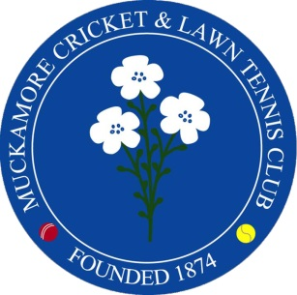 |  |  |  | Antrim
 |  |  |  | BT41 1QR
 |  |  |  | (028) 9446 6684 |info@mcltc.com | www.mcltc.com
Hi Folks
It’s me again to let you know it’s that time of the year when membership is due and the good news is that, once more, the rates have stayed the same.
To remind you what your fee covers:
General rates | Insurance | Electric | Phone line | Security | Water rates
Bank fees | Waste | NCU fees | Cricket equipment | Machinery | Repairs
Fertiliser | Grass seed | Loam | Bar wages | Accountant | Etc, etc, etc

This list is not exhaustive and for clarity, your fees do not go towards paying for a club professional.
All the things mentioned above need paid for and without membership fees, we cannot function – setting aside the not insignificant matter that you are not insured. It is not fair that most members pay readily and subsidise those who don’t, so to that end, if you have not paid your fees by 30th April 2021, you will not be picked for any team and will not be allowed access to the club or its facilities, including practicing. There will also be a £50 levy for late payment – all of the above will be strictly enforced.

MEMBERSHIP FEES
FAMILY £300 | ORDINARY £160 | 18~21/FULL TIME STUDENT £80 | UNDER 18 £50
SENIOR CITIZEN £50 | ORDINARY NON-PLAYING £50 | MIDWEEK/CORPORATE/LADIES £100 | ASSOCIATE £30
After a review, we now required to have an audit trail for payments, so it will have to be by bank transfer; by cheque to MCLTC; by PayPal or by standing order – this can be spread over a number of months but must be fully paid by 30th April 2021.
Bank details are (Please put your name as a reference):
Account name: MCLTC
Sort code: 95 02 02
Account no. 01015710

I would be grateful if you could advise if you are no longer a member so I can take you off the list.
Finally, we need a membership form for everyone to cover us for GDPR and insurance. You can either print off, complete and post to me at:
28 Mull Road, Antrim. BT41 2TR
Alternatively, give to any committee member or email it back to me muckmaorememberships@gmail.com
Thanks for your co-operation and if you have any queries, please email or phone 07549 832505.
Yours in sport

Sarah Keates
Membership secretary.

